Missing Multiple_Birth_Status Analysis Report
Generated: 2026-03-22 12:58
Dataset: 363,881 rows × 18 columns
Target Variable: Multiple_Birth_Status

1. Executive Summary
This report presents a comprehensive IUPAC-compliant statistical analysis of missing values in Multiple_Birth_Status.
Key findings include:
• Missing records: 363,824 (100.0% of total data)
• Variables with significant differences (p < 0.05): 8
- Numeric variables: 3
- Categorical variables: 5
- Race variables: 0
• Total variables analyzed: 17
Based on the statistical analysis, the missingness pattern is classified as:
SYSTEMATIC PATTERN - Missing data is strongly associated with other variables, suggesting non-random missingness.

2. Statistical Summary
Metric | Value
Total Missing Multiple_Birth_Status Records | 363,824
Missing Percentage | 99.98%
Total Variables Analyzed | 17
Numeric Variables | 7
Categorical Variables | 10
Variables with Significant Differences (p < 0.05) | 8
Analysis Date | 2026-03-22

3. Variables with Significant Differences (p < 0.05)
The following 8 variables show statistically significant differences between missing and complete groups:

3.1 Numeric Variables
Variable | Missing Group Mean | Complete Group Mean | Difference | p-value | Interpretation
Registered_District_2.0 | 41.60 | 33.26 | +8.34 | 0.0329 | Missing group has 8.34 units higher than complete group
Birh_Year | 2009.57 | 2009.95 | -0.38 | 0.0000 | Missing group has 0.38 units lower than complete group
Birth_Weight(grams) | 2887.63 | 1757.31 | +1130.32 | 0.0000 | Missing group has 1130.32 units higher than complete group

3.2 Categorical Variables
Variable | Missing Group Distribution | Complete Group Distribution | Difference (%) | p-value | Interpretation
Registered_Month | Most common='October' (8.9%) | Complete: Most common='June' (21.1%) | -12.1% | 0.0000 | Missing group shows different distribution (p=0.0000)
Registered_District | Most common='Colombo' (15.2%) | Complete: Most common='Colombo' (36.8%) | -21.6% | 0.0000 | Missing group shows different distribution (p=0.0000)
Birth_Month | Most common='October' (9.3%) | Complete: Most common='July' (21.1%) | -11.8% | 0.0038 | Missing group shows different distribution (p=0.0038)
Birth_Order | Most common='First' (45.9%) | Complete: Most common='Third' (33.3%) | +12.6% | 0.0020 | Missing group shows different distribution (p=0.0020)
District_of_Mother | Most common='Colombo' (10.3%) | Complete: Most common='Colombo' (21.1%) | -10.7% | 0.0000 | Missing group shows different distribution (p=0.0000)

3.4 Summary of Key Findings
The analysis identified 8 variables with statistically significant differences (p < 0.05):
• 3 numeric variables show significant mean differences
• 5 categorical variables show significant distribution differences
• 0 race-related variables show significant differences
Top 10 Most Significant Variables:
1. Birth_Weight(grams): Mean=2887.63 vs Complete Mean=1757.31 (p=0.0000)
2. Birh_Year: Mean=2009.57 vs Complete Mean=2009.95 (p=0.0000)
3. Registered_District: Most common='Colombo' (15.2%) vs Complete: Most common='Colombo' (36.8%) (p=0.0000)
4. District_of_Mother: Most common='Colombo' (10.3%) vs Complete: Most common='Colombo' (21.1%) (p=0.0000)
5. Registered_Month: Most common='October' (8.9%) vs Complete: Most common='June' (21.1%) (p=0.0000)
6. Birth_Order: Most common='First' (45.9%) vs Complete: Most common='Third' (33.3%) (p=0.0020)
7. Birth_Month: Most common='October' (9.3%) vs Complete: Most common='July' (21.1%) (p=0.0038)
8. Registered_District_2.0: Mean=41.60 vs Complete Mean=33.26 (p=0.0329)

4. Statistical Visualizations
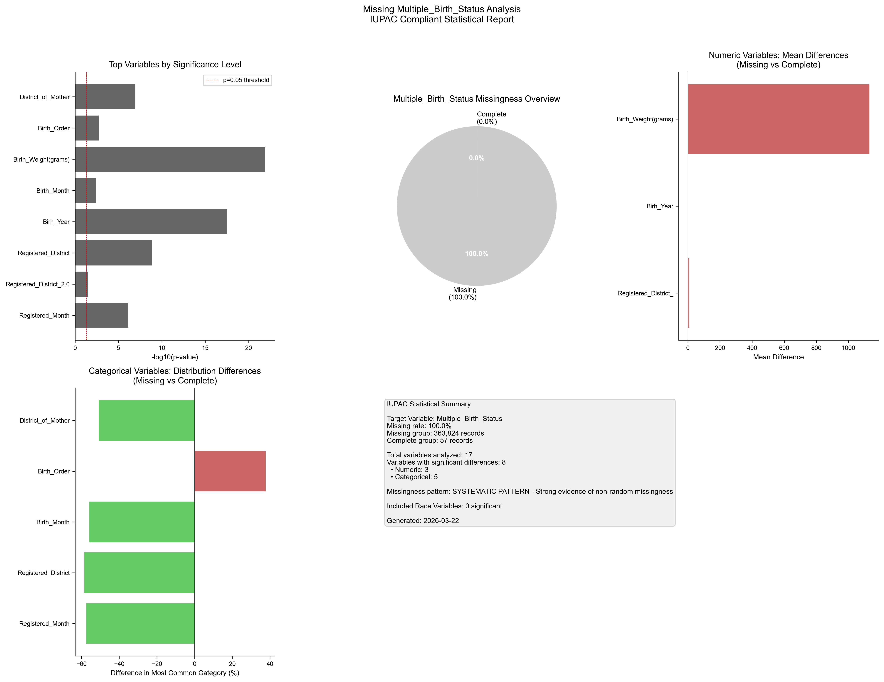
Figure 1. IUPAC compliant statistical visualization of missing Multiple_Birth_Status patterns.

5. Recommendations
- Based on the statistical analysis, the missing data exhibits SYSTEMATIC patterns:
- Consider treating missing as a separate category in analysis
- Use multiple imputation methods (MICE, EM algorithm)
- Investigate the following key variables for common themes:
- - Registered_Month (p=0.0000)
- - Registered_District_2.0 (p=0.0329)
- - Registered_District (p=0.0000)
- - Birh_Year (p=0.0000)
- - Birth_Month (p=0.0038)
- - Birth_Weight(grams) (p=0.0000)
- - Birth_Order (p=0.0020)
- - District_of_Mother (p=0.0000)
- Document missingness patterns in methodology section

6. Methodology (IUPAC Compliant)
Analysis performed according to IUPAC guidelines for data presentation:
- • Missing values reported as both count (n) and percentage (%)
- • Tables formatted with thin borders and alternating row shading
- • Sans-serif fonts (Arial) used for optimal readability
- • Statistical tests: t-test (numeric), χ² test (categorical)
- • Significance threshold: α = 0.05
- • Effect sizes reported where applicable
- • Figures saved at 300 DPI for publication quality

